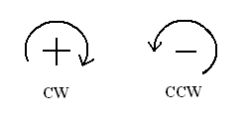
$\boxed{SLOPE DEFLECTION EQUATION}$

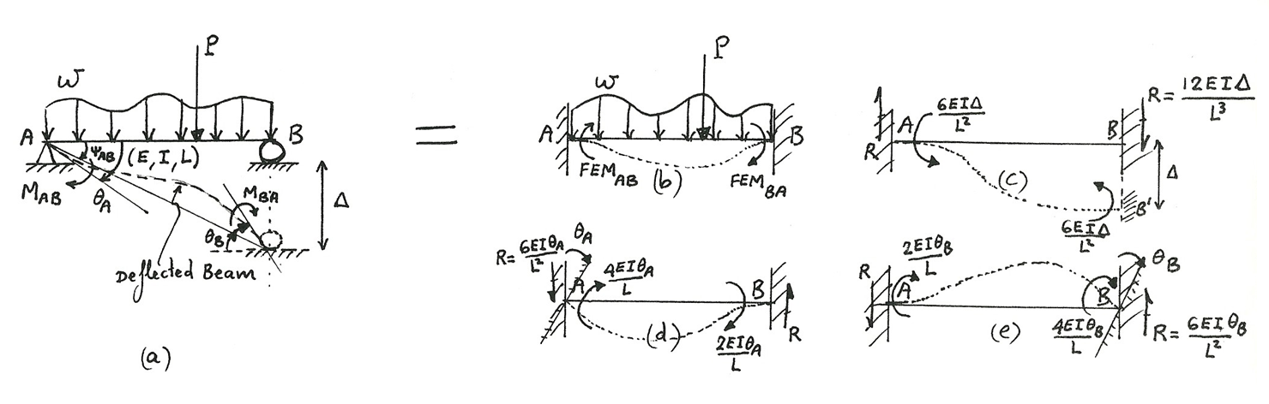

The end-moments of Figure (a) = $\sum{( end Moments of Figures b+c+d+e )}$

Thus:

$M_{AB}= {FEM}_{AB}+ \left(-\frac{6EI∆}{L^{2}}\right)+ \left(+ \frac{4EIθ_{A}}{L}\right)+ \left(\frac{2EIθ_{B}}{L}\right)=2E\left(\frac{I}{L}\right)\left[2θ_{A}+θ_{B}- 3\left(\frac{∆}{L}\right)\right]+{FEM}_{AB}$

$$M_{BA}= {FEM}_{BA}+ \left(-\frac{6EI∆}{L^{2}}\right)+ \left(+ \frac{2EIθ_{A}}{L}\right)+ \left(\frac{4EIθ_{B}}{L}\right)= 2E\left(\frac{I}{L}\right)\left[2θ_{B}+θ_{A}- 3\left(\frac{∆}{L}\right)\right]+{FEM}_{BA}$$

Note:

$$Ψ_{AB}≡Chord rotation of beam= Ψ_{BA}=\left(\frac{∆}{L}\right)=(_{- IF CCW}^{+ IF CW} )$$

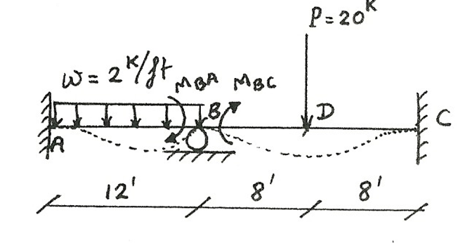
Example 1: Beam (no settlement, no-sideways effects)

Step 1: Identify all geometrical unknowns
(Such as rotation, translation at certain joints)
1 unknown =$θ_{B}$.

Step 2: Obtain the corresponding number of equation(s)
(Hint: by writing equilibrium eq(s) at the same place with the unknowns! )

$\sum{M_{B}=0 ↔} M_{BA}+ M_{BC}=0$___________________________________(50)

Step 3: Applying the slope Deflection Equation (SDE) formula to Eq.(50)

$$+\frac{wL^{2}}{12}= {}_{CW}^{+}{24}$$
$M_{BA}=2E\left(\frac{I}{12}\right)\left[2θ_{B}+θ_{A}-3\left(Ψ_{BA}= \frac{∆}{L}\right)\right]+ {FEM}_{BA}$ __________________(52)

Zero

$$- \frac{PL}{8}= \frac{-\left(20^{K}\right)({16}^{'})}{8}={}_{CCW}^{-}{ 40}$$
$M_{BC}=2E\left(\frac{I}{16}\right)\left[2θ_{B}+θ_{C}-3\left(Ψ_{BC}\right)\right]+ {FEM}_{BC}$ ______________________ (53)

Hence: $2E\left(\frac{I}{12}\right)\left[2θ_{B}\right]+ 24+2E\left(\frac{I}{16}\right)\left[2θ_{B}\right]- 40=0$__________________ (51)

$M_{BA}$ $M_{BC}$

Step 4: Solve for all unknown displacement and/or rotations (see Eq.51):

$θ_{B}= + \frac{192}{7EI}$ ___________________________________________ (54)

Step 5: Solve for all the end-moments, by referring to SDE Formula:

$M_{BA}= \frac{4EI(θ_{B}= \frac{192}{7EI})}{12}+ 24=33.{13}^{Kft}$ And $M_{AB}= \frac{2EIθ_{B}}{12}- 24=_{CCW}^{-}19.43$

$M_{BC}= \frac{4EI(θ_{B}= \frac{192}{7EI})}{16}-40=-33.13$ And $M_{CB}= \frac{2EIθ_{B}}{16}+40=43.43$

Step 6:

Support reactions can be found from Free Body Diagrams (FBD) and statics equilibrium.
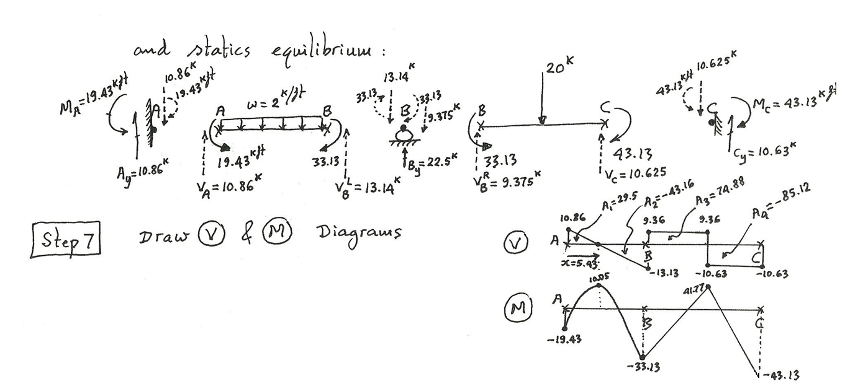

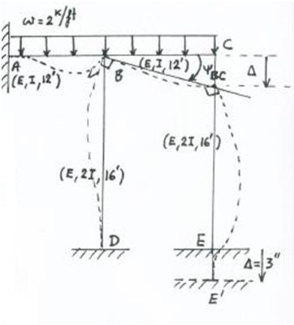
Example 2: SDE with settlement for 2-D frame (units = K, ft.)
Settlement at support $E= ∆ =3^{''}↓ =\left(\frac{3}{12}\right)ft$
Chord rotation for member $BC = Ψ_{BC}= \frac{+ 3''}{12 ft}=\frac{3^{ft}}{{144}^{ft}}$

From SDE formula:

$$M_{AB}=2E\left(\frac{I}{12}\right)\left[θ_{B}\right]- (\frac{wL^{2}}{12}≡24)$$

$$M_{BA}=2E\left(\frac{I}{12}\right)\left[2θ_{B}\right]+ (\frac{wL^{2}}{12}=24)$$

$$M_{BC}=2E\left(\frac{I}{12}\right)\left[{2θ}_{B}+ θ_{C}- 3(Ψ_{BC}= \frac{+∆}{L}= \frac{3}{144})\right]+(FEM_{BC}= -\frac{wL^{2}}{12}=-24)$$

$$M_{CB}=2E\left(\frac{I}{12}\right)\left[{2θ}_{C}+ θ_{B}- 3*(\frac{3}{144})\right]+(FEM_{CB}= \frac{+wL^{2}}{12}=+24)$$
(55)
$$M_{BD}=2E\left(\frac{2I}{16}\right)\left[2θ_{B}\right]$$

$$M_{DB}=2E\left(\frac{2I}{16}\right)\left[θ_{B}\right]$$

$$M_{CE}=2E\left(\frac{2I}{16}\right)\left[2θ_{C}\right]$$

$$M_{EC}=2E\left(\frac{2I}{16}\right)\left[θ_{C}\right]$$

- 2 unknowns: $θ_{B}, θ_{C}$ ?
- 2 equilibrium equations :
$\sum{M_{B}}=0 {}_{=}^{}{{ M}_{BA}+ }{ M}_{BC}+ { M}_{BD}$ ______________________________ (56)
$\sum{M_{C}}=0 {}_{=}^{}{{ M}_{CB}+ }{ M}_{CE}$ _____________________________________ (57)
- Substituting Eq. (55) into Eqs. (56, 57) , one obtains:
$0= f_{1}$($θ_{B}, θ_{C}$) _______________________________________________ (58)
$0= f_{2}$($θ_{B}, θ_{C}$) _______________________________________________ (59)
- Solving Eqs. (58, 59) simultaneously to obtain:
$θ_{B}= {known}_{1}$______________________________________________ (60)
$θ_{C}= {known}_{2}$______________________________________________ (61)

- Substituting Eqs. (60 & 61) into Eq. (55) to obtain all end-moments.
- From FBD of member(s) and joint(s), and using statics equilibrium Eqs., to get all support reactions!

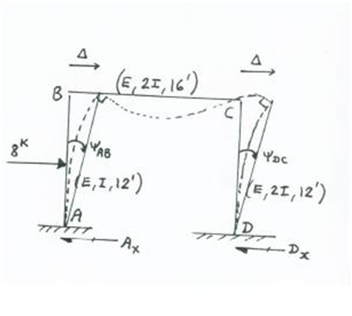
Example 3: SDE with Side-Way Effects

From SDE formula:

$$M_{AB}=2E\left(\frac{I}{12'}\right)\left[θ_{B}- 3(Ψ_{AB}= \frac{+∆}{L})\right]+ (FEM_{AB}= -\frac{PL}{8}=-12)$$

$$M_{BA}=2E\left(\frac{I}{12}\right)\left[2θ_{B}-\frac{3∆}{12} \right]+ (12)$$

$$M_{BC}=2E\left(\frac{2I}{16}\right)\left[{2θ}_{B}+ θ_{C}\right]$$
(62)
$$M_{CB}=2E\left(\frac{2I}{16}\right)\left[{2θ}_{C}+ θ_{B}\right]$$

$$M_{DC}=2E\left(\frac{2I}{12}\right)\left[θ_{C}- 3(Ψ_{DC}= \frac{+∆}{12'}\right]$$

$$M_{CD}=2E\left(\frac{2I}{12}\right)\left[2θ_{C}- 3\frac{∆}{12}\right]$$

Free Body Diagrams and Static Equilibrium:

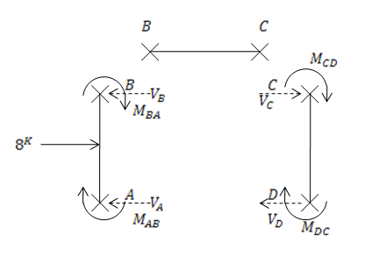

- From FBD of column AB:
$$\sum{M_{B}=^{}0= M_{BA}}- \left(8^{k}\right)\left(6^{'}\right)+M_{AB}+ \left(V_{A}\right)\left({12}^{'}\right)$$

Thus: $V_{A}= \frac{{48}^{Kft}-M_{BA}- M_{AB} }{12}$ ________(63)

- From FBD of column DC:
$$\sum{M_{C}=^{}0= M_{CD}}+M_{DC}+ (V_{D})({12}^{'})$$

So: $V_{D}= \frac{-M_{CD}- M_{DC} }{12}$_______________________________(64)

- Substituting Eq. (62) into Eqs. (63 and 64) to get:
$V_{A}= f_{1}$($θ_{B}, ∆$)
___________________________________(65)
$V_{D}= f_{2}$($θ_{C}, ∆$)

- System Equilibrium at Joint B:
$\sum{M_{B}= M_{BC} {+ M}_{BA}=0}$ ____________________________________________(66)

- System Equilibrium at Joint C:
$\sum{M_{C}= M_{CB} {+ M}_{CD}=0}$____________________________________(67)

- System $\sum{F_{x}= + 8^{K}-V_{A}-V_{D}=0}$
Or: $8^{K}-f_{1}$($θ_{B}, ∆$)$-f_{2}$($θ_{C}, ∆$) = 0_______________________________(68)

- Substituting Eq. (62) into Eqs. (66 and 67) to obtain:
$2E\left(\frac{2I}{16}\right)\left[{2θ}_{B}+ θ_{C}\right]+ 2E\left(\frac{I}{12}\right)\left[ {2θ}_{B}- \frac{3∆^{ft}}{{12}^{'}}\right]+ {12}^{Kft}=0$__________(69)

$2E\left(\frac{2I}{16}\right)\left[{2θ}_{C}+ θ_{B}\right]+ 2E\left(\frac{2I}{12}\right)\left[ {2θ}_{C}- \frac{3∆^{'}}{{12}^{'}}\right] =0$__________(70)

- Simultaneously solve 3 Eqs. (68 $→$70), one obtains:

$\begin{matrix}θ_{B} \\ θ_{C} \\ ∆\end{matrix} = \begin{matrix}-7.351/EI \\ 19.959/EI \\ 256.734/EI\end{matrix}$_______________________________________(71)

- Substituting Eq. (71) into Eq. (62) to get:
$M_{AB}= -23.956 ({or}_{CCW}^{}$) And$M_{BA}= -1.214(_{CCW}^{}$)

$M_{BC}=+1.214^{Kft} ({or}_{CW}^{}$) And $M_{CB}=$+ 8.092

$M_{CD}=-8.092$ And $M_{DC}=$-14.742

- Draw moment M Diagram.

