Physics 413, Methods of Experimental Physics

Experiment Q2: Electron e/m ratio

Introduction:
In this experiment you will determine the ratio of the charge and mass of the electron. This is called the specific charge of the electron.

Theory:
When an electron with charge e moves with velocity v through a magnetic field B, it experiences a force given by:

F = e v × B

Since the force is always perpendicular to the direction of motion, the electron moves in a spiral path. In particular, when the magnetic field is perpendicular to the velocity, then the electron moves in a circle of radius r determined by the balance between the Lorentz (magnetic) force and the centripetal force needed to go in a circle:

evB = mv²/r

where m is the mass of the electron. So that

r = mv/eB

In this experiment, the electron gains its initial velocity by passing through a potential difference V. Thus,

v = (2eV/m)^{0.5}

so that we have

e/m = 2V/(B² r²)

The magnetic field which bends the beam is supplied by two Helmholtz coils, two parallel N-turn coils of wire of radius a, separated by a distance 2a. The plane of the coils is vertical so that the magnetic field is horizontal. The electron beam emerges perpendicular to the magnetic field, midway between the coils, and on the axis of the coils. The magnetic field on the axis of a single wire loop is
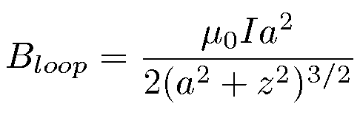
where a ≈ 10 cm is the radius of the loop, I is the current, and z is the distance from the center of the loop. The magnetic field at the center of the pair of Helmholtz coils is
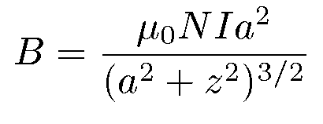
where N is the number of turns of each of the Helmholtz coils. The coils consist of between 100 and 200 turns of wire each and are connected in series.

Aparatus:
The equipment consists of two parts, a three-element vacuum tube and a set of Helmholtz coils, both mounted on the same base. Within the vacuum tube, an electron gun is mounted vertically along its central axis. This gun consists of an indirectly heated cathode which supplies the electrons, a plate held at high positive potential to accelerate the electrons, and a grid between the plate and the gun to focus the electrons. There is also a horizontal disk mounted at the upper end of the electron gun. The disk has four circles marked on it at radii 0.5, 1.0, 1.5, and 2.0 cm. The circles and the bulb surface are coated with a material that fluoresces when struck by the electron beam. The tube contains a trace amount of inert gas to aid in focusing the beam and to make the beam path visible.

The magnetic field can be adjusted by changing the current in the Helmholtz coils. The velocity of the electrons can be adjusted by changing the accelerating potential between the cathode and the plate. By adjusting the magnetic field and the electron velocity, the electron beam can be made to describe a semicircle and hit the disk traveling vertically downward. If the beam hits one of circles marked in the disk, then the radius of curvature of the beam can be measured precisely.

Knowing the radius of curvature, accelerating voltage, and Helmholtz coil current, one can then determine e/m.

Operating the electron gun:
- Filament: The filament current heats the cathode so that it emits electrons. It takes about two minutes for the cathode to warm up enough to start emitting electrons. After the initial warm up, the current should be as low as possible to still produce a well-focused visible electron beam. The lower the filament current, the weaker the electron beam and the longer the life of the (very expensive) tube. The warm-up current should be about 0.5 A (either AC or DC) and should not exceed 0.6 A. The voltage is typically less than 6 V. A 1 A fuse protects the filament from excessive circuit. Use a separate ammeter to monitor the current; it is much more sensitive than the ammeter on the power supply. EQUIPMENT WARNING: After warm-up, reduce the filament current as low as possible (typically between 0.4 and 0.5 A) while still producing a visible electron beam.
- Plate: The operating range is +60 to +136 volts. It should never draw more than a few milliamperes. If it does, reduce the filament current. Adjusting the plate voltage changes the electron velocity. Use a separate voltmeter (not shown) to precisely measure the voltage. EQUIPMENT WARNING: Turn off the plate voltage except when making measurements.
- Grid: This intermediate electrode focuses the electron beam. The grid voltage should be positive and less than the plate voltage. Start at 0 V and adjust as necessary.
Connect the leads as shown in Figure 1. The dedicated e/m power supply has four supplies. A one to six volt AC supply (unused) on the left hand side, a 20 A, 5 V DC supply on the right hand side with its own ammeter (used to power the filament current), and two DC power supplies in the middle, sharing a common voltmeter. The left-middle supply should be used for the plate and the right-middle supply should be used for the grid.

Connect the black terminals of the three supplies to the left-hand filament terminal (as shown in Figure 1). This is the common return. Connect the red terminals of the three supplies as shown. Use a separate ammeter (not shown) in series with the filament power supply to monitor the filament current. Use a separate voltmeter (not shown) to measure the Plate voltage.
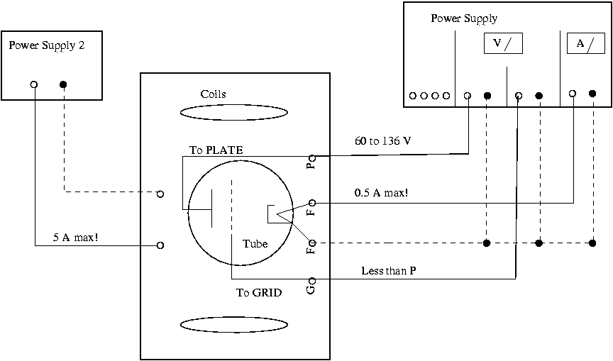
Figure 1: Wiring diagram for connecting the power supplies to the e/m apparatus. It shows the interior of the electron gun schematically. Note: the connections on the apparatus are already made. Only the external connections to the power supplies need to be made.

Operating the Helmholtz coils:
Connect a second power supply (that can supply at least 12 V and 5 A to the Helmholtz coils. Use a separate ammeter (if necessary) to measure the current precisely. SAFETY WARNING: The Helmoltz coil connectors are not insulated. Do not touch them when current is flowing. Do not exceed 5 A. You will need to determine the number of turns in the coils, their radius and their separation.

Procedure:
- Position the apparatus away from stray magnetic fields.
- Connect the power supplies to the apparatus.
- Turn on the power supply to the filament heater (current = 0.5 A). Allow it to warm up for two minutes.
- Apply 100 V to the Plate.
- Darken the room or place a dark cloth over your head and the apparatus. You should see a vertical electron beam.
- Adjust the Grid voltage to focus the beam to a diameter of less than 2 mm. Keep the Grid voltage less than the Plate voltage.
- Reduce the filament current if possible. Since the current heats the cathode, there will be a delay between reducing the current and seeing its effects.
- Apply a current to the Helmholtz coils. See the electron beam bend. Use a small compass to determine the direction of the magnetic field.
- Adjust the Helmholtz current so that the beam strikes one of the rings of the disk. Do not exceed 5 A.
- Record the values (Filament current, Plate voltage, Grid voltage, Helmholtz current, voltage and polarity, disk ring radius) in your log book.

Data Collection:
Record the data for
- Three well spaced Plate voltages between 60 and 136 V
- All four rings on the disk, if possible. Not all rings can be reached at all Plate voltages.
- Two polarities of the magnetic field

Data Presentation:

Plot your data several ways:
- As a function of plate voltage
- As a function of bend radius
- As a function of magnetic field
- As a function of field polarity
- As a histogram (frequency plot)

In a perfect experiment, the values of e/m would be independent of other variables.

Uncertainties:

There are several sources of error and uncertainty in this measurement.
- measuring uncertainty:
- Plate voltage
- Coil current
- Beam radius
- Stray magnetic fields
- Earth’s magnetic field
- Magnetic fields from power supplies, etc
- Non-vertical initial electron velocity (since the entire tube is in the magnetic field). Try to observe this effect and compensate for it.
- Manufacturing tolerances

Measuring uncertainties can be reduced by using accurate and precise meters and by taking care in centering the beam on the ring.

The effects of stray magnetic fields can be reduced by measuring with both magnetic field polarities. If you get large differences between measurements at the two polarities, reposition your apparatus away from potential sources of stray fields and repeat the measurements.

Plot all of your measurements to see if there are systematic shifts in the data for certain experimental conditions (e.g.: you might get a larger value of e/m for larger values of the Plate voltage). Discuss these in your write up.

You should estimate your measurement uncertainty two ways:
- Estimate the uncertainty in each quantity that enters your calculation of e/m and calculate the uncertainty in the final quantity.
- Histogram the measured values of e/m. The rms deviation of your measurements is an experimental measure of the uncertainty.
These two methods should be in reasonable agreement.

References:

- Any good Modern Physics or E&M book.
- Experimental Atomic Physics, Harnwell and Livingood.
- Experiments in Modern Physics, Melissios.

Dr. D.C. Cook
Dept of Physics
Old Dominion University
1984

Modified 2007
L. Weinstein, ODU

