Spectroscopy of Gamma Radiation
Physics 413

Old Dominion University

Introduction: Many radioactive isotopes emit gamma rays (high energy photons) when they decay from an excited state to a lower state (frequently the ground state). Measuring the energies of these gamma rays lets us determine the energy levels of some nuclei in the same way the measuring optical atomic spectra lets us determine the atomic energy levels. For example, the isotope Cesium-137 decays by beta-emission to an excited state of Barium-137. The excited Barium-137 nucleus then decays by 0.662 MeV photon emission to its ground state. We use scintillation detectors to measure the gamma ray energies. These detectors are named because they scintillate (give off a flash of light) when struck by a high-energy particle. There are many different materials used in scintillation detectors, including plastic, Sodium-Iodide (NaI), Germanium, etc. The materials are typically doped to improve their light production and collection efficiencies. The different materials differ in their energy resolution, speed, timing resolution, and cost.

In this experiment you will use a Sodium-Iodide (NaI) detector, and a MultiChannel Analyzer (MCA). The pulse height spectra of the gamma sources Cobalt-60 (⁶⁰Co) and Cesium-137 (¹³⁷Cs) will be used to calibrate the MCA. These results will let you measure the energies of radiation emitted by Sodium-22 (²²Na).

Experimental: The NaI detector that you will use consists of several parts:
- a NaI crystal, which emits light when a high-energy particle interacts with it
- a PhotoMultiplier Tube (PMT), which converts the emitted light to electrons in a photocathode, and then multiplies the electrons. This requires an applied voltage of +1000 V to operate. (Note that the appropriate voltage [and polarity] will vary tremendously depending on the PMT.)
- an amplifier to further amplify the PMT signal. This requires a standard cable to connect to a standard amplifier voltage.
- a protective housing around the entire detector
Note that there are several connectors on the end of the detector. There is a D-connector for the amplifier power. There are 1-2 BNC connectors for the signal output. There is one SHV connector (similar to a BNC connector, but better insulated and intended for high voltage up to about 5 kV).

(1) Connect the high voltage power supply to the detector using the HV cable. Connect the signal to a oscilloscope (at least 1 MHz). Put a radioactive source on the detector and examine the signals on the scope. Record the polarity and the typical amplitudes, rise times, and decay times. Now connect the amplifier power supply (either from a NIM crate or from the MCA) and examine the signals again. Make sure that the signals are well enough separated in time that they do not overlap each other. You can use a regular oscilloscope for this or use LabView.

(2) Now connect the output of the detector to the input of the MCA. The MCA maps signal pulse height to channel number. Put a ¹³⁷Cs near the MCA. Record the spectrum. When you plot the number of counts versus channel number, you should see something like:
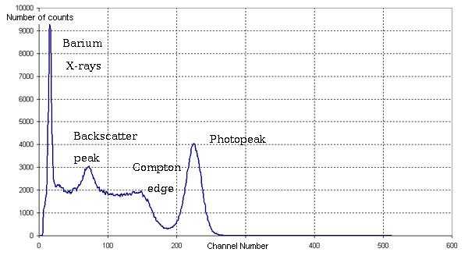
Note that the channel numbers (x-axis) will depend on the gain of the detector and the sensitivity of the MCA. The number of counts (y-axis) will depend on how long you count for. There are several features to the spectrum.
- The photopeak corresponds to absorption of the gamma ray by the scintillator. In this case, the photon transfers all of its energy to an electron via the photoelectric effect. The struck electron then interacts with atomic electrons as it travels through the scintillator, exciting the atomic electrons which emit light as they deexcite.
- Energies at and below the Compton Edge can correspond to the elastic scattering of the photon from an atomic electron. The energy transferred to the electron depends on the scattering angle of the photon. The maximum electron energy occurs at 180º scattering. The Backscatter peak occurs at the energy of the backscattered photon. (Thus, the energy of the Compton edge plus the energy of the backscatter peak equals the energy of the photopeak.)
- The low energy peak is due to internal conversion of the gamma ray.
We are interested primarily in the energies of the photopeaks.

(3) In order to calibrate the experimental set up to that you can convert the channel numbers to energies, you will need to measure several peaks of known energy. In this experiment, you will measure the photopeaks of ¹³⁷Cs and ⁶⁰Co to calibrate the detector. You should determine the peak locations by fitting the spectra.

The experimental decay schemes of ¹³⁷Cs and ⁶⁰Co are shown below:
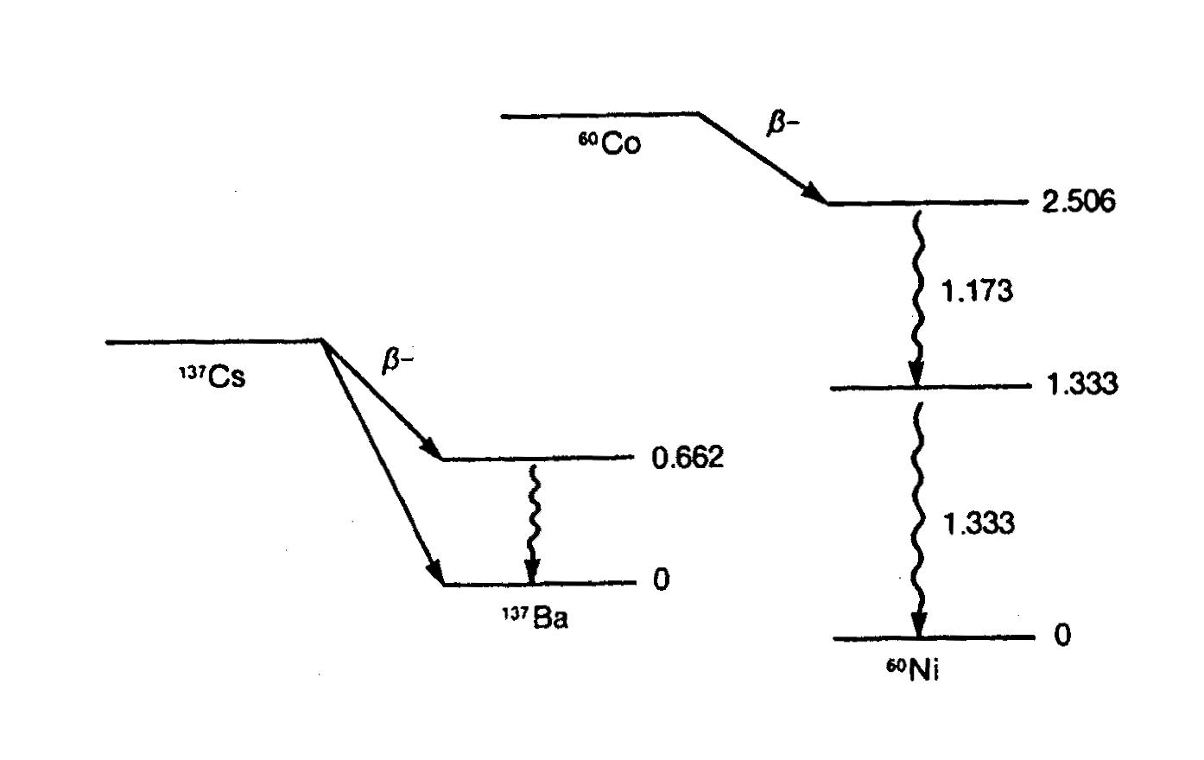
(4) After you have calibrated the MCA, you should measure the spectrum of Sodium-22 (²²Na) and determine the energies of its two peaks (with uncertainties). Decide what the sources of the peaks are.

Possible sources of experimental error:
- Temperature variation
- High voltage variation
- Rate dependence of the detector. Note the decay times of the signals. If the rate is too high, a second signal might occur before the first signal has ended. In this case, it will add itself to the tail of the first signal and give and erroneous result.

Lawrence Weinstein
24 Jan 2008

